
The minutes of the meeting of Satterthwaite Parish Council in the Parish Room, Satterthwaite on Monday 7th September 2026 at 7.30 pm.
Item
1 | Welcome and Introductions  Apologies  None
2 | Declarations of interest  - To receive declarations by elected and co-opted members of disclosable pecuniary interests in respect of items on this agenda
3 | Requests for Dispensations  - The clerk to report any requests received since the previous meeting for dispensations to speak and/or vote on any matter where a member has a disclosable pecuniary interest.
4 | Minutes  - Chair to review and sign last meetings minutes on 13^{h} July 2026  Accepted as accurate record
5 | Public participation  - To receive comments and representations from members of the public in relation to any item on the agenda  - To dial in residents attending remotely where applicable
6 | Updates on ongoing issues and actions from last meeting  Review of action log  - Playground quotes – All quotes required for playground but seeking a third supplier for the tennis courts.  - Village Parking – Planning application rejected -complaint re: overall process sent to LDNPA – no acknowledgement after 2 emails. Will escalate to more senior management. Advice to send in new application by Angus Hutchinson, planning consultant, covering items on drainage specifically.  - Moor lane and motorcyclists – no update  - Community resilience plan – first draft complete, discussion with Chair of Parish Room Committee tomorrow to finalise. Will include electricity and power cuts as part of this.  - Shape future plan response - completed  - Unity banking - completed  - Dale park caravans – LDNPA following up and will action as appropriate
7 | Items for meeting not covered above  - Wall up towards Hill Top houses – to clarify exact position of concern where issue is. Awaiting inspection from builder.  - Parking on Church Lane – discuss with holiday cottage owners again re: signposting and if needs holiday cottage parking advice changing. Further issues with vehicles blocking Church Lane.  - Gritting for winter – approved, to be co-ordinated by Hawkshead Parish Council.
8 | Additional or urgent points to raise regarding Parish or Councillor matters  Mountain bike club for village – application for grant funding once further details understood
9 | Items for the Lengthsman  Nil specific at present. Work continuing as needed around valley.
10 | Planning Consultations sought from Parish Council  - 7/2026/5391 Installation of 4 wooden installations along the Millwood trail – no consultation needed. Noted.  - 7/2026/5333 Sewage Treatment plant installation Bank cottage – granted.
11 | Accounts since last meeting  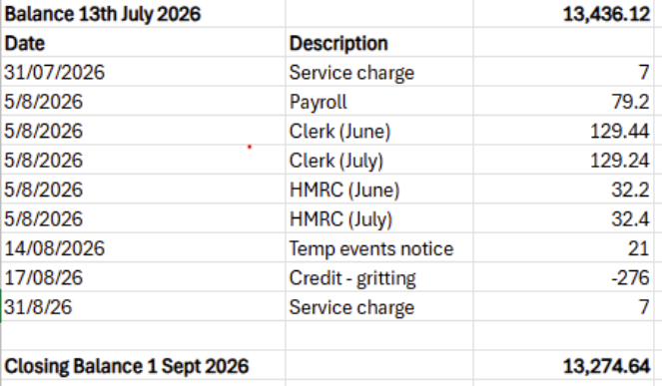  Agreed as accurate and reconciled by Cllr Nickson.
12 | Extra Mile bookable bus service – been successful as a concept. To promote in village for use by local residents. To consider planning a village event in the near future.
13 | Tour de France 2027 – event planning - send in next newsletter.
14 | LDNPA Rusland woodland management plan – concerns re: fire risk if trees are cut and branches left especially with recent heat waves.
15 | Community Governance review final recommendations – decision to keep same boundaries for Parish by Westmorland ad Furness.
16 | Community Safety Partnership Plan for 2027-30 – survey ends 18th September – noted.
17 | Potential creation of bridleway through LDNPA woodlands – Colton & Satterthwaite - response by ‘middle of September’ – to respond and support the proposition.
18 | Kendal Urgent Treatment Centre engagement – noted and sent to community via village emails and newsletter.
19 | Joy Maker recruitment – noted and sign up instructions distributed to community.
20 | National salary scales for Clerks – noted. No change for Satterthwaite Parish Council.
21 | National Public Confidence in Policing Survey – To distribute to community.
22 | Village BBQ 5th September in the playground – very successful, to send thanks to community and Parish Room Committee.
23 | Agenda items for next meeting  Potential Tour de France event for village  Any updates on planning for car park  Resilience community plan  Playground contract decisions
24 | Next meeting date to be agreed  October 19th 7:30pm Satterthwaite Parish Room  November 30th 7:30pm Satterthwaite Parish Room

